NAME:S.Rushi Keshava Reddy
Reg No:192472355
SUBJECT CODE:CSA0606
SUBJECT NAME: Design and Analysis of Algorithms
------------------------------------------------------------------------------------------------Q30. Application: Cybersecurity Threat Analysis System
#include <stdio.h>
#include <math.h>

int main() {
int n;
double T = 1;

printf("Enter n: ");
scanf("%d", &n);

for (int i = 2; i <= n; i++) {
T = T + i * log2(i);
}

printf("T(%d) = %.2f\n", n, T);

return 0;
}
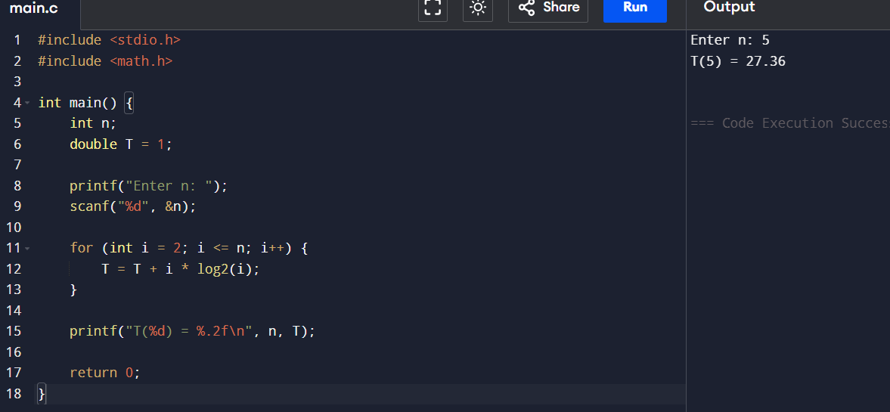
Report
- Title: Cybersecurity Threat Analysis System
- Objective: Solve the recurrence $T\left(n\right)=T\left(n-1\right)+n\log{n}$using the substitution method.
- Complexity: O(n² log n)
- Result: The algorithm's running time increases as O(n² log n) with increasing threat data.

Q70. Application: Firewall Packet Inspection System#include <stdio.h>
#include <stdio.h>

int main() {
int n, key, i, found = 0;

printf("Enter number of rules: ");
scanf("%d", &n);

int rules[n];

printf("Enter rule IDs:\n");
for(i = 0; i < n; i++)
scanf("%d", &rules[i]);

printf("Enter packet rule ID to search: ");
scanf("%d", &key);

for(i = 0; i < n; i++) {
if(rules[i] == key) {
found = 1;
break;
}
}

if(found)
printf("Packet matched at position %d\n", i + 1);
else
printf("Packet not matched\n");

return 0;
}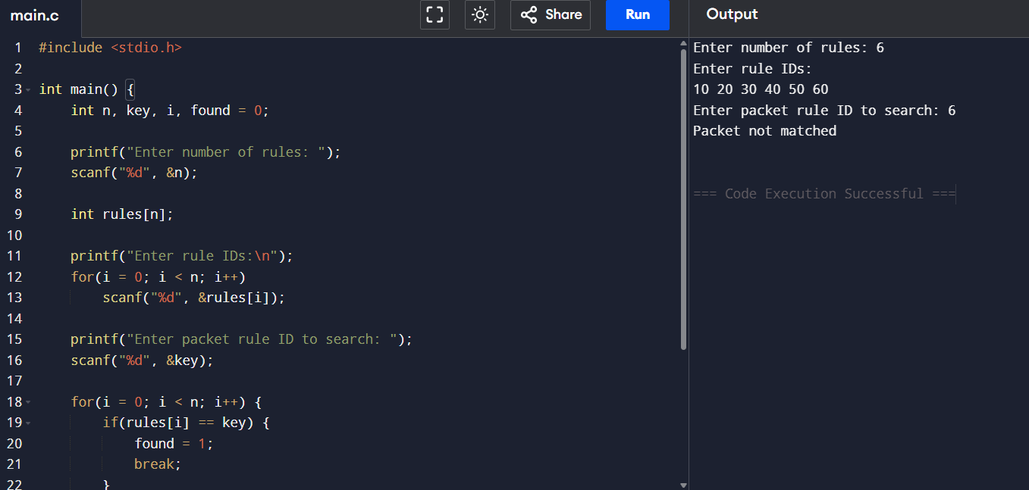
Report
• Title: Firewall Packet Inspection System
• Objective: Perform sequential (linear) search to inspect packets.
• Time Complexity: O(n)
• Space Complexity: O(1)
• Result: The search time increases linearly as the number of firewall rules grows.

